Instructions for using the Terminal to run python code:

1. If you are using a Linux operating system or already have Ubuntu installed, skip these steps for download.
2. To download Windows subsystem for Linux, open terminal on your computer and run the command wsl --install
3. Close out of the terminal and re-open in Ubuntu
4. Download miniconda (which holds python packages) by running this command: curl https://repo.anaconda.com/miniconda/Miniconda3-latest-Windows-x86_64.exe -o miniconda.exe 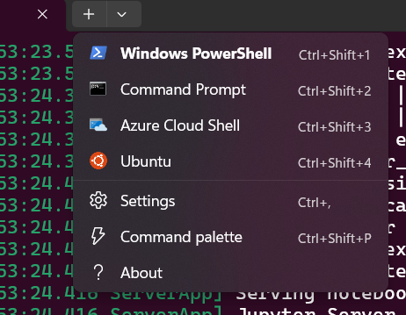

start /wait "" miniconda.exe /S

del miniconda.exe

1. Once installed and restarting the terminal create an environment for your project(s) by running the command: conda create --name <your-env-name>
   1. Refer [here](https://conda.io/projects/conda/en/latest/user-guide/tasks/manage-environments.html) for more information
2. Activate that environment by running: conda activate <your-env-name>
3. Create a folder for your code by running: mkdir <chosen_name>
4. Navigate to the folder by running: cd <chosen_name>
5. For more information on basic ‘bash’ functions refer [here](https://www.freecodecamp.org/news/bash-scripting-tutorial-linux-shell-script-and-command-line-for-beginners/)
6. Download jupyter notebook by running: conda install jupyter notebook
7. Activate jupyter notebook by running: jupyter notebook
   1. It should either give a link or automatically go to the internet browser for jupyter notebook. From there you can open a python notebook

The ANML [github](https://github.com/ANMLboisestate?tab=repositories) has a repository of some code for different plotting of data.